I’m sure everyone would agree making sure you are paid for the work you do is a top priority. But we are not always following best practices to ensure we are getting paid in a timely fashion. There is a new feature in SmartWare that is intended to help you manage your A/R more efficiently.

Most A/R is some type of warranty – Manufacture (MW), Extended (EW) or Home (HW). In Zware there really wasn’t a way to ensure you had filed all claims and many used a “work around” so they could ensure their claims were filed before marking them Ready-To-Invoice. This feature could also be used for any 3rd Party Biller – does not have to be warranty because the Claim Submitted checkbox doesn’t affect anything in the work order. The sole purpose is to give you an easy way to keep track of filing claims for payment.

The new feature allows you to move all work orders through the system and not miss filing a claim. Managing A/R then becomes much more efficient because all work orders with a balance owed will be in one place.

On each work order there is a box at the bottom of the page on the left when you are looking at the Summary page of the work order (Options 🡪 Summary).

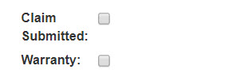

The box simply labeled “Warranty” should not be check manually – it is for Manufacturer Warranty only and is checked automatically when the Dispatch Code MW is selected.

The Claim Submitted box is to be checked once you have filed the claim. When you **Finalize** work orders any work orders that have a balance will move to A/R All and you’ll see a column under A/R All that allows you to easily see if the Claim Submitted box is checked or not. If you file the claim after the work order is in A/R All you can still open the work order and check the Claim Submitted box. Therefore, there is no reason not to move work orders forward by Reviewing and Finalizing all work orders.

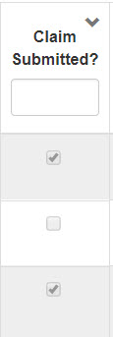

You can also filter the columns in any of the Accounting > Invoicing screens by using the filter boxes. For example, if you want to see all Manufacturer Warranty work orders you could filter in two ways.

To filter by Dispatch code, type the Dispatch Code in the box immediate under the column heading.

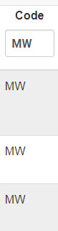

Of you could select Warranty on the drop-down in the far right column of the screen. This would be used to filter manufacturer warranty only as it is selecting only those that have the Warranty box checked on the work order. Remember that box is only checked when you select your Manufacturer Warranty Dispatch Code. Those work orders treat parts differently because they are no cost to you.

