**Using Job Skill Field on Work Order for More Efficient Routing**

By Deborah McKenney

In a perfect world all your technicians would be full-line technicians – able to be sent on any service call that comes your way. Every Mr. Appliance owner would be working toward that goal because it gives you more flexibility and eliminates the worry of a technician leaving you that has a special skill your other technicians don’t have. But, alas, it is not a perfect world. Sometimes you have new technicians that specialize in a certain line of appliances (laundry, refrigerators, etc.) and other times you have a trainee that has limited ability and you’re sending them to easier jobs at first.

All that makes your office less efficient, but there is a feature in SmartWare that would allow you to effectively use the Routing Scheduler and the Router and still trust that only technicians qualified for the job will be assigned to that job.

The Router looks at several variables when it selects the technician and the placement of the job in the route. One of those criteria is Job Skill. There are now three additional Skill Levels you could use:

Specialty

Specialty 2

Specialty 3

Let’s say you have a new technician that only works on laundry appliances and you decide to use the Job Skill of Specialty.

First you would ensure that each technician that can be sent to repair washers and/or dryers would have the Job Skill of Specialty setup in their Employee Record in SmartWare.

If all your technicians can repair washer and dryers, then all of them would need the Specialty Job Skill. The technician that can ONLY do laundry appliances would have just one Job Skill – Specialty.

This is done under ADMINISTRATIVE --> EMPLOYEES.

Select the employee to update by clicking on the Edit icon to the left of the employee’s name.

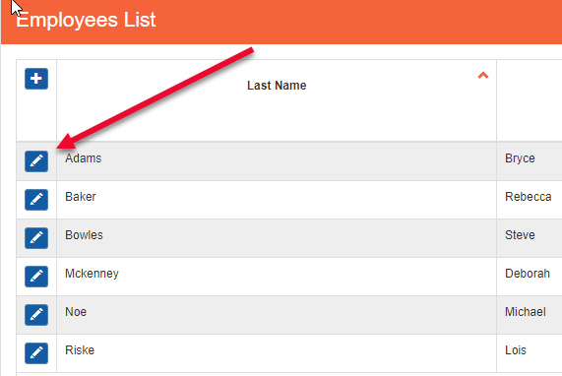

1. Click in the box labeled JOB SKILLS
2. Select the appropriate Job Skill(s) for the technician and Save.

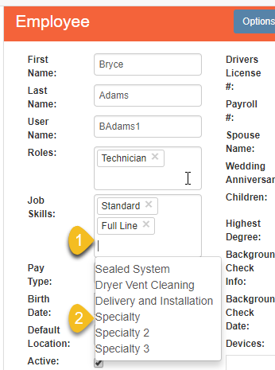

When CSRs are creating Work Orders they would then use the Specialty Job Skill for all washer and dryer jobs. When you run the Router it will only send those techs that have that Job Skill in their Employee Record.

If you have any further questions about how you can use the Job Skill field to make your office more efficient, please don’t hesitate to contact your FC.