Monitor the Amount of Home & Extended Warranty as a Percentage of Jobs & Revenue
& How to Setup Dispatch Codes
By Deborah McKenney

The Owner’s Dashboard in SmartWare shows you the percentage of your jobs and revenue that is generated from manufacturer warranty. The percentages are derived from the work orders because the Warranty box on the work order is checked. When you select the Manufacturer Warranty dispatch code the Warranty box will automatically be checked. You would never check this box manually as it treats parts on the work order differently.
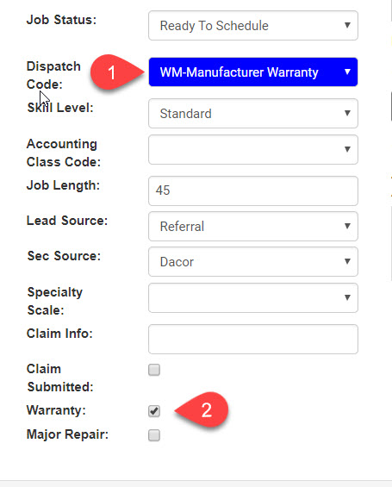
The Owner’s Dashboard does not indicate the percentage of jobs and revenue done for extended or home warranty, but It is equally important to monitor how much of that work you’re doing because it is unadvisable to do 20+% of any work coming from a single source. Doing too much work from any one source puts your company at risk should that source dry up and it can happen.
Here’s where the Dispatch Code report in SmartWare comes into play. The report will show you the percentage of the work you are doing for each of the Dispatch Codes you use routinely in your office.

Click on Reports All Reports
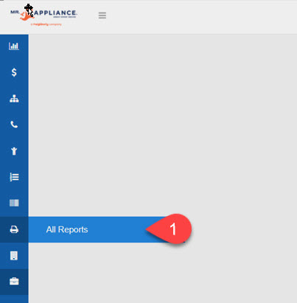
Select Dispatch Code report from drop-down menu
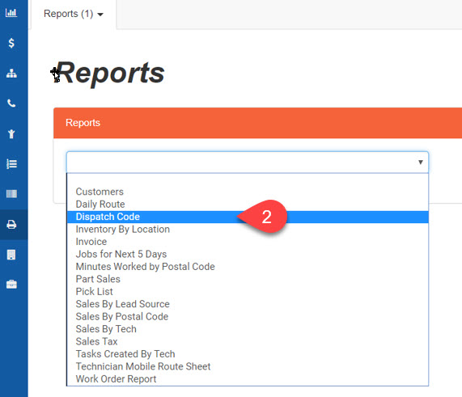
Enter desired date range and click Run Report button

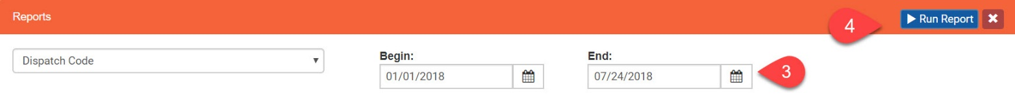
At the top of the report you will see the number of pages; in this case 84 pages. The first page is the summary page which shows the number of jobs, percentage of jobs, total revenue, percentage of revenue, and the job average for each dispatch code you use. The subsequent pages provide detail – a list of the work orders that fall into each dispatch code group. In this case you can see that this franchise is doing some extended warranty (EW) at the rate of 5.49% of jobs and 5.9% of revenue.
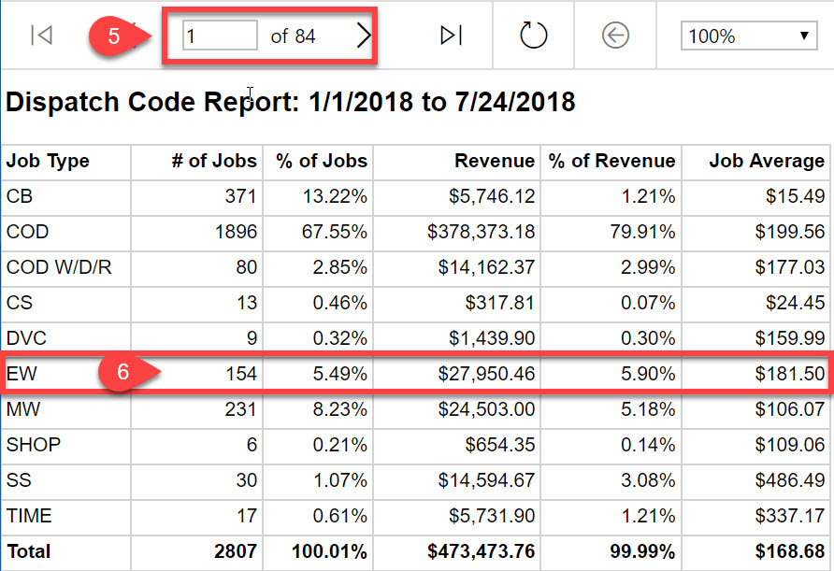

To download the report into an Excel spreadsheet, click on the print icon and select Excel from the drop-down menu.
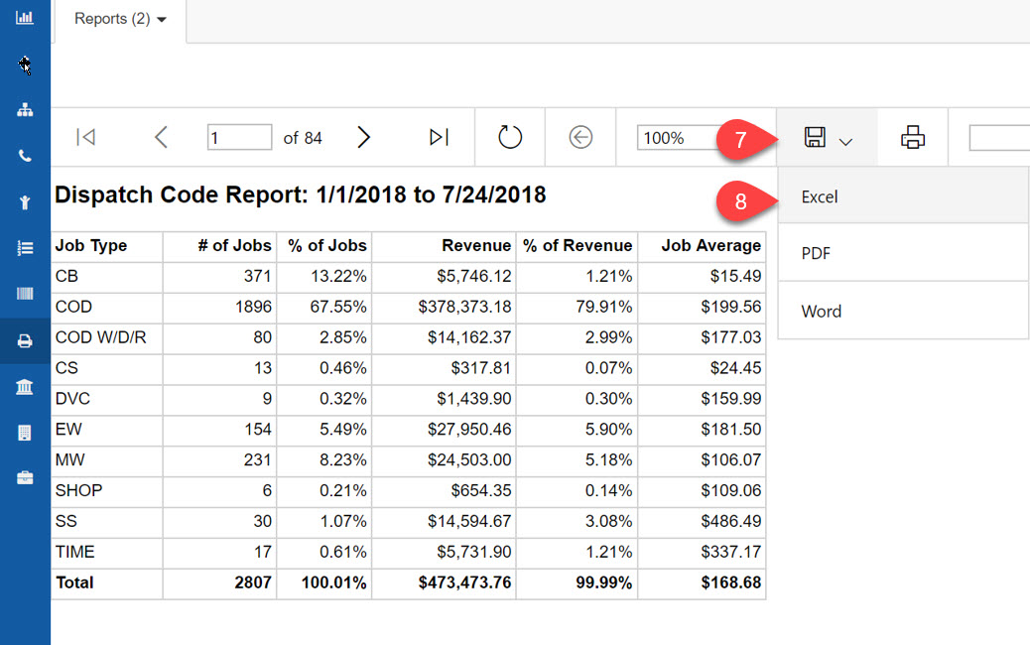
I recommend monitoring home and extended warranty separately as they are very different types of warranty. If you do not have a Dispatch Code for both, here’s how to add a Dispatch Code.

Go to Franchise Setup > Setup
Select Dispatch Codes from the Options drop-down menu
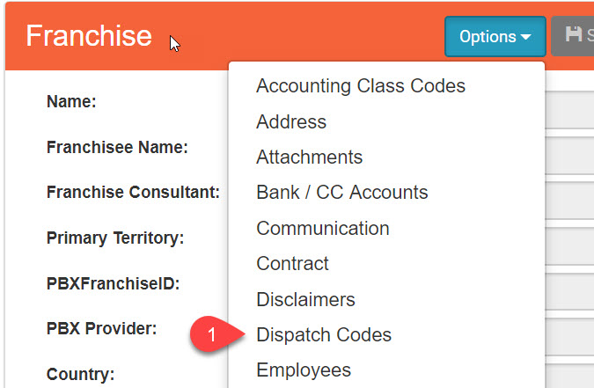

Click on plus sign (+) to add a new Dispatch Code
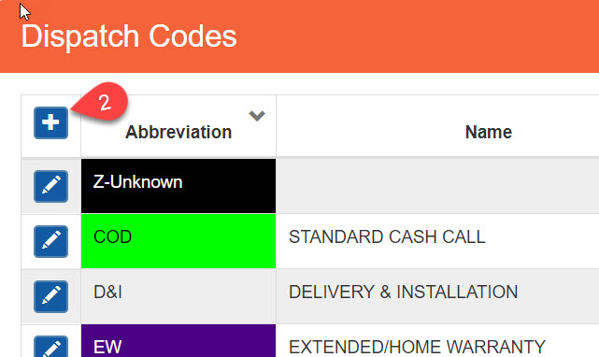
Setup the details for the Dispatch Code & Save. Note; Number 6 below – select No for extended and home warranty. It would only be Yes for manufacturer warranty only – remember, parts on the work order are handled differently for manufacturer warranty.
