

12/4/2017 SmartWare Best Practice:
In Zware there was a handy feature that allowed you to see if anyone else in the network had a part you were looking for … parts that you might not be able to get locally or quickly may be sitting in someone else’s warehouse.
That feature has to be turned on by each of you to allow others to search your inventory.
- To do so, go to SETUP FRANCHISE > SETUP
- From the Options drop-down select Options
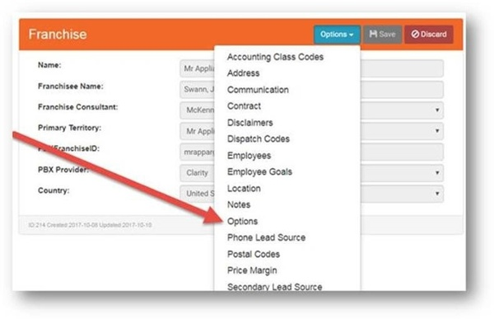
On the right side of your screen you’ll see a list of "Franchise Options." There is a Search box at the bottom of the list.
- Type "Inventory" into the box and the option will come up called “Allow Inventory Search.”
- Click on the "Edit" icon to the left of the option to change the default from false to true.
- Save.
- Please take a moment to do this. Read on to see how to search for parts other franchisees may have that you are looking for.
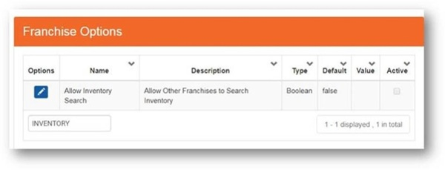

To Search other databases for needed parts:
- Go to MATERIAL > PARTS
- Type in the Manufacturer Part Number.
- Click on the "Edit" icon to the left of the part you are looking for.
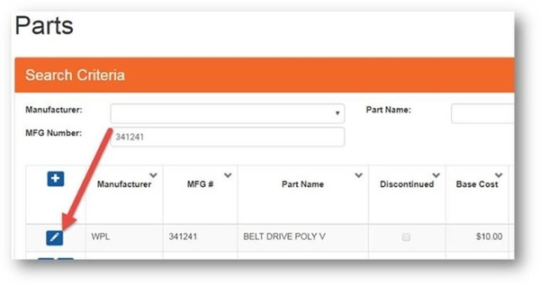
- On the right side of your screen click on the "Options" droop-down and select Global Inv (Global Inventory)
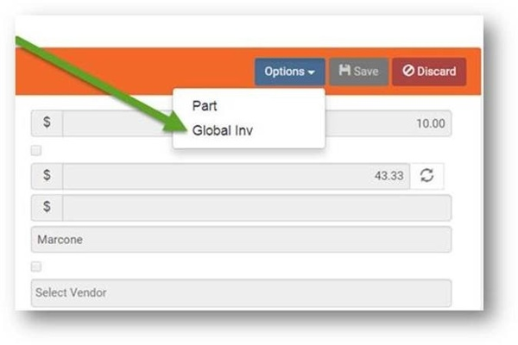
You will then see a list of franchisees that have the part in stock and the quantity in stock. As of right now, you only have the name of the franchise – we are looking into providing the name of the owner and contact info. For now, if you don’t know you the owner is, you are welcome to email and ask for the contact info.
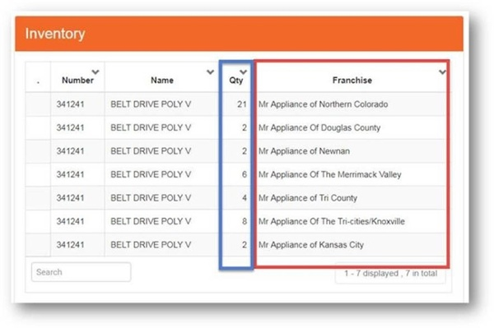

We hope you found these SmartWare best practices helpful. If you need any assistance executing these strategies, please reach out to your Franchise Consultant. They'll be happy to help.

Sincerely,
Glenn Lewis
Vice President Operations, Mr. Appliance

Mr. Appliance / Dwyer Group, Inc.  1010 N University Parks Dr. Waco, TX 76707 USA  You received this email because you are subscribed to Franchisee Communications from Mr. Appliance and Dwyer Group, Inc..  Update your email preferences to choose the types of emails you receive.  Unsubscribe from all future emails | 

